**Mesoscale Lab 1 – Ising/Potts**

1. All tests passed for the site energy function in Matlab grader.

2. All tests passed for the Glauber dynamics function in Matlab grader.

2. Below the curie temperature all the sites tend to move towards a single spin. This occurs once energy reaches zero and magnetization reaches one. Above the curie temperature the magnetization will stay around zero with no upward trend as the number of sweeps increases. Based on the plots below the curie temperature is somewhere near 2.5 and 2.6 for this system.

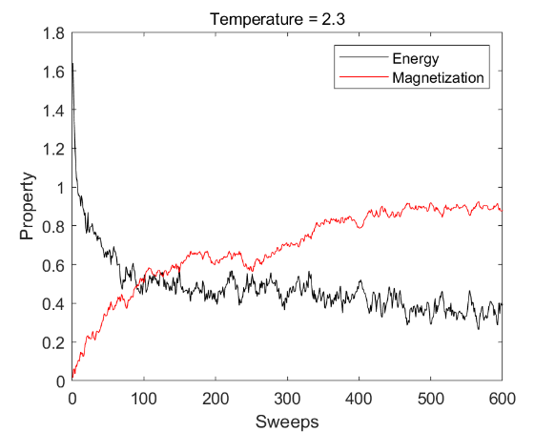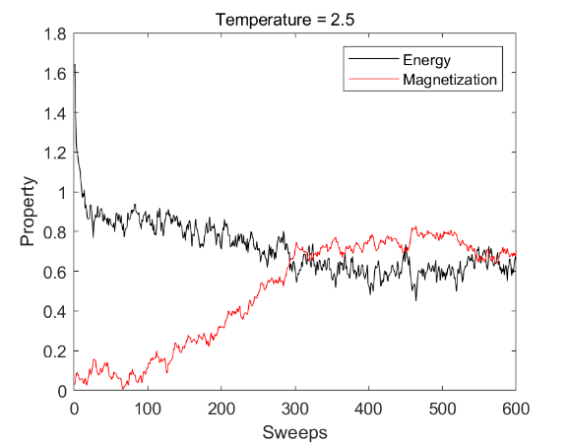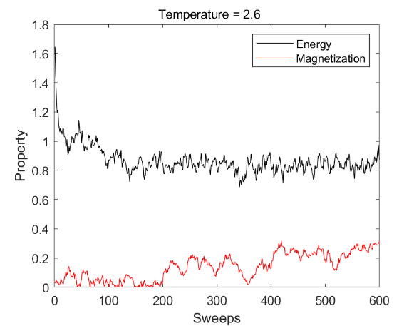

3. Magnetization versus temperature plot for the system. Here the curie temperature is evident as the point where magnetization drops from 1 to 0. Before the curie temperature all the spins are aligned and after the spins are all random. 2.5 is the approximate curie temperature according to the plot.

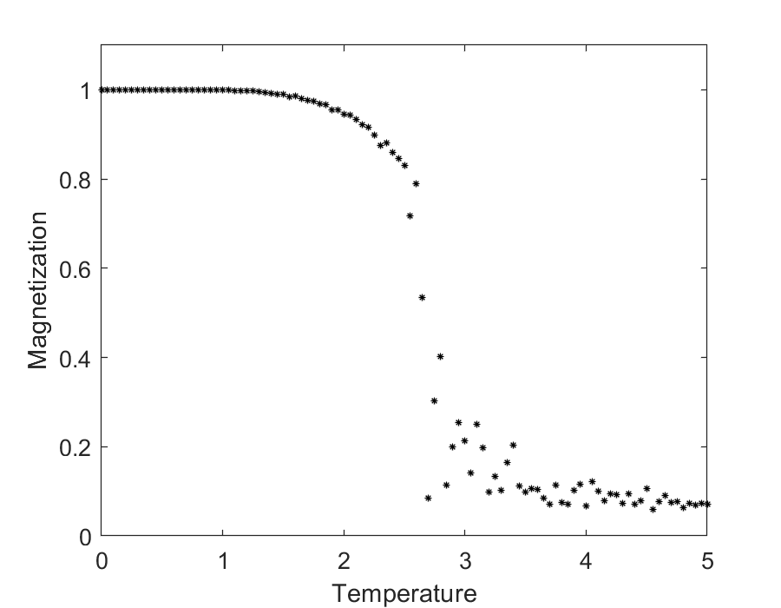

4. The snapshots below are the results of a 100 by 100 Potts system of 300 sweeps for 5 different spins and a temperature of 0.1. The number above each image denotes the number of sweep. The model shows coarsening, the larger ‘grains’ grow and the smaller grains shrink with time.

